Statement
INSERT INTO Location(LocNo,FacNo,LocName)
VALUES ('L107','F104','Door');

Before (7 rows)
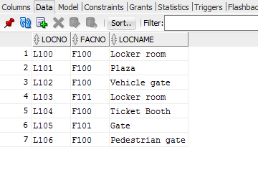

After(8 rows)
